**Validation**

Please follow the below examples to validate that you have successfully installed the BlueSnap cartridge.

**Business Manager:**

All cartridge components are located in "Merchant Tools -> BlueSnap Setting -> BlueSnap Setting".

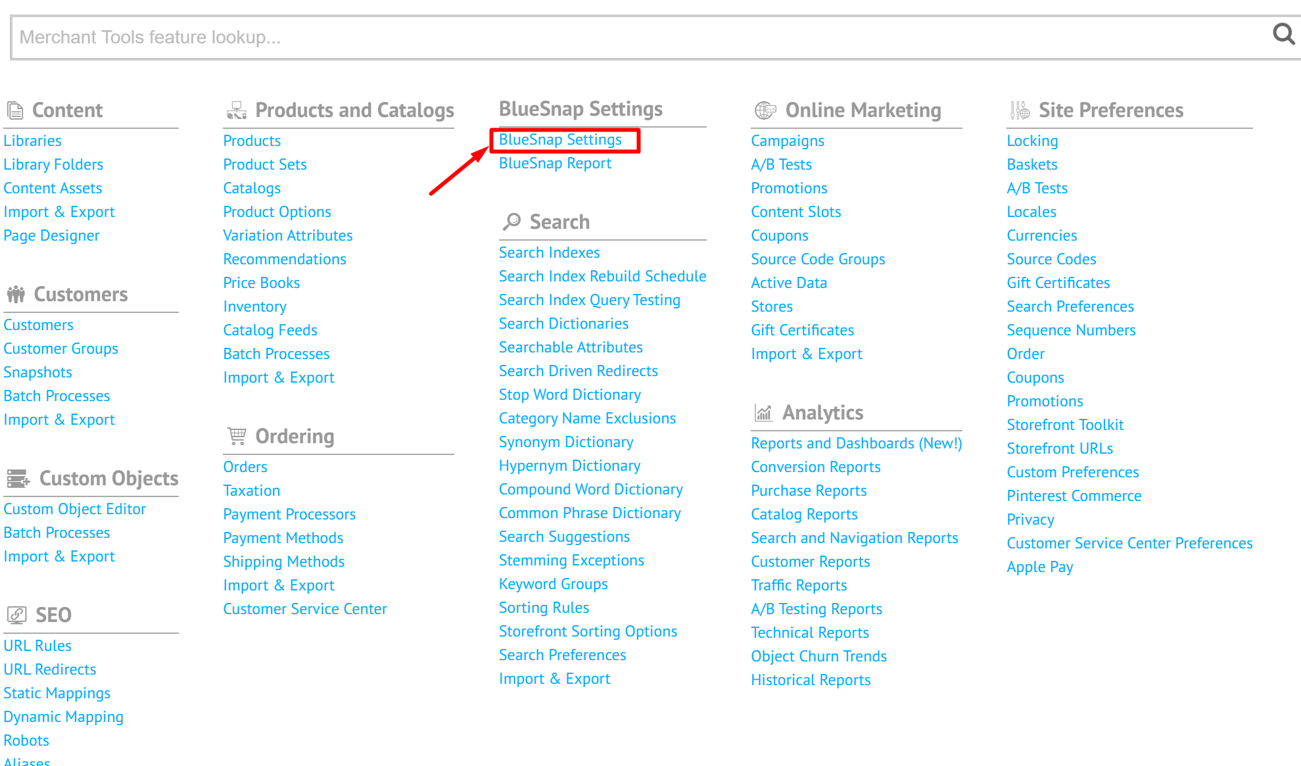

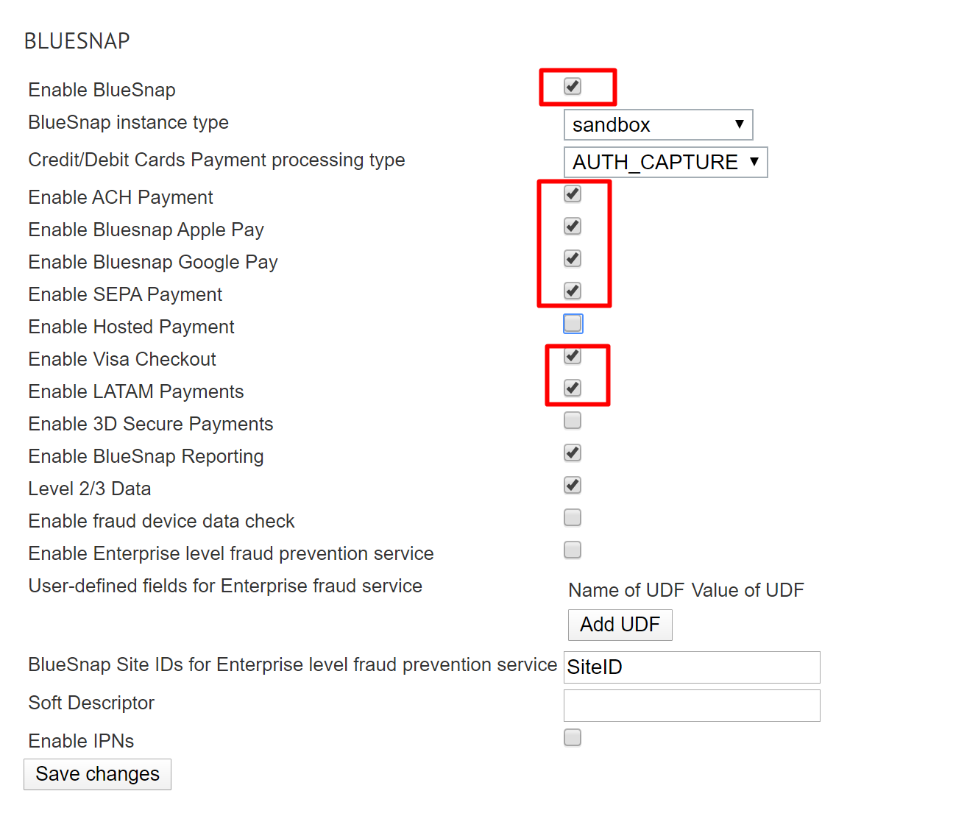

Make sure that the BlueSnap cartridge option and payment methods are turned on

In the order payment section, in addition to the credit card payment form, BlueSnap payment methods will become available as a separate payment method.

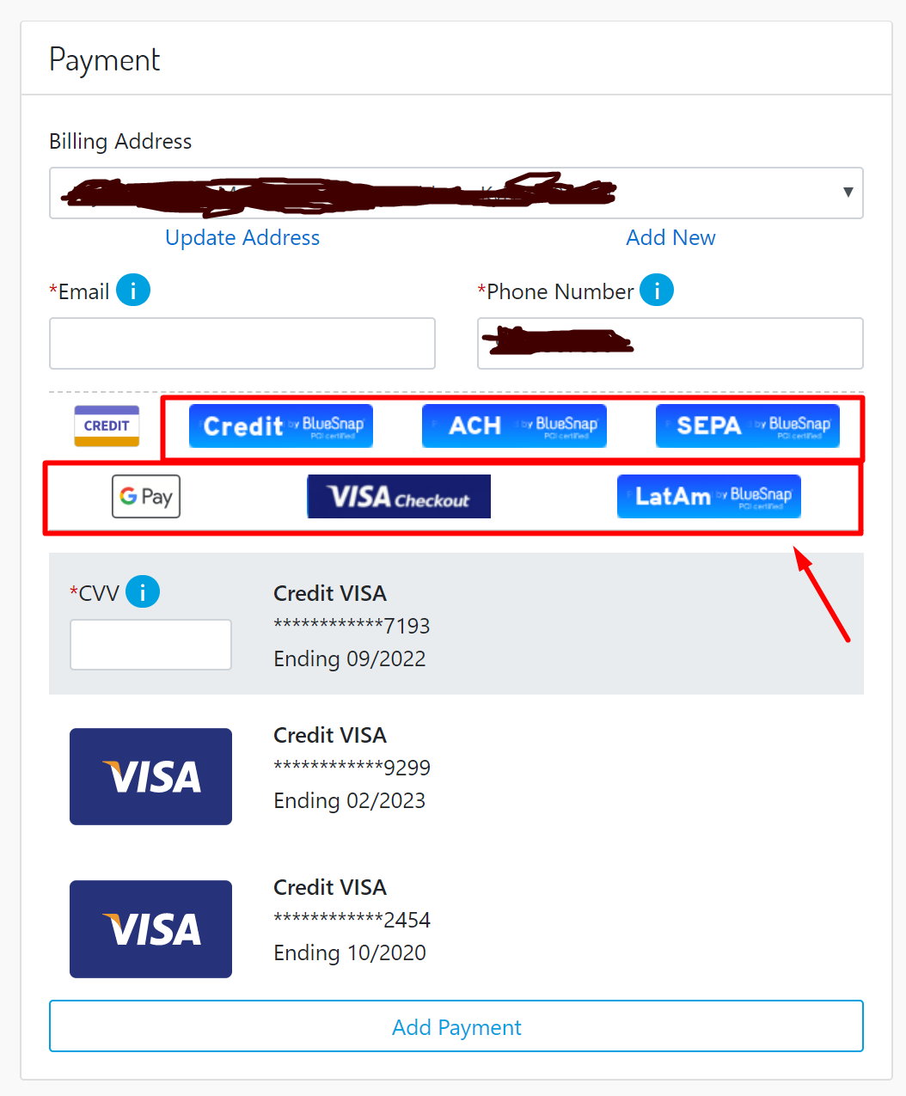

In the "My Account" section, the "BlueSnap Vault" section will become available, where the customer can save their payment instruments.

